**Overview for Task 2 of the Magic Carpet Ride Task Sequence** **(Back to Top)**

Main Goal: To develop informal ideas about span in a 2D setting (drawing on a metaphor of “getting anywhere” using 2 modes of transportation corresponding to vectors).

By the end of the lesson students should be able to:

* Conclude that there is nowhere that Gauss can hide
* Explicitly compare various graphical and algebraic justifications to this conclusion
* Articulate why / how the vector equation c1[ 3 1] + c2[1 2] = [a b] means that you can get anywhere in R2 that Gauss tries to hide

The instructor should:

* Introduce the formal definition of span
* NOT mention Linear (in)dependence (this comes up in Task 3)

**Task 2 of the Magic Carpet Ride Task Sequence** **(Back to Top)**

**Handout 2: Hide-and-Seek**

An image of Handout 2 is given below. See page 45 for a printable student version of the handout.

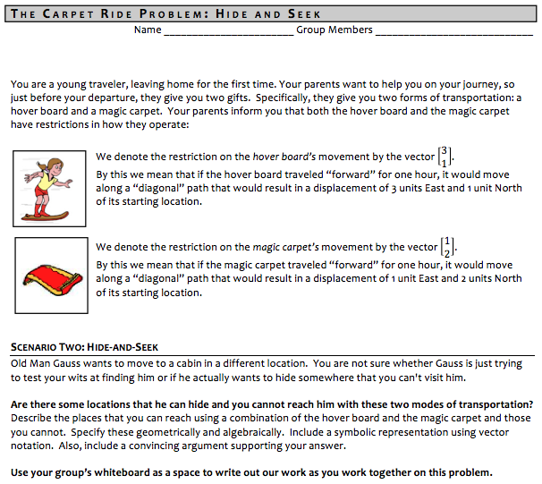

**Task 2 of the Magic Carpet Ride Task Sequence** **(Back to Top)**

**Handout 2: Hide-and-Seek**

**Learning Goals and Rationale**

**Goals**

The main goal of the problem on Handout 2 – Hide-and-Seek – is to determine whether there is any location where Old Man Gauss can hide so that a person would be unable to reach him using the same two modes of transportation from the previous problem.

More generally, the goal is to help students develop the notion of span in a two-dimensional setting before formalizing the concept with a definition.

**Rationale**

We wrote the Hide-n-Seek task the way it is because it presents an intuitive way to get at the notion of span. Students’ work in Task 1 (determining how to get to Gauss if he lives at (107,64) focused on one particular linear combination. This task, which asks students if Gauss can hide, focuses on all possible linear combinations of the two transportation vectors. As part of this process students should realize that with these two modes of transportation (vectors), they can indeed get anywhere. The bulk of the classroom discussion is on the ways students can come to see this geometrically and algebraically. In doing this, the task reemphasizes that all real-valued scalars are viable and how to interpret negatives in the MCR task setting.

The culmination of the task is being able to define span formally using standard symbolic notion while having students have a sense of this as being “all the places you can get” with a set of vectors. We also note that we asked “Can he hide?” versus “Where all can you get?” because asking students to focus on a series of single points (possible hiding places) naturally leads to an exploration of all possible locations whereas focusing immediately on all possible locations might not push students to consider particular points within the space.

**Task 2 of the Magic Carpet Ride Task Sequence** **(Back to Top)**

**Handout 2: Hide and Seek**

**Student Thinking**

At the heart of students’ difficulties in this task is the issue of developing a coherent geometric interpretation for linear combination of vectors with all possible cases for sign combination of scalar coefficients. As students work on this task, they begin to develop the ability to conceptualize movement in the plane using combinations of vectors. In looking at the definition of span, it may seem obvious that a task intended to help students develop an intuitive understanding of span should require students to investigate the idea of linear combinations in depth. However, we see here that it is a non-trivial task for students to explore and develop a concept image for span in which all possible linear combinations of vectors are conceptualized in a coordinated way. Below are 6 examples of student work.

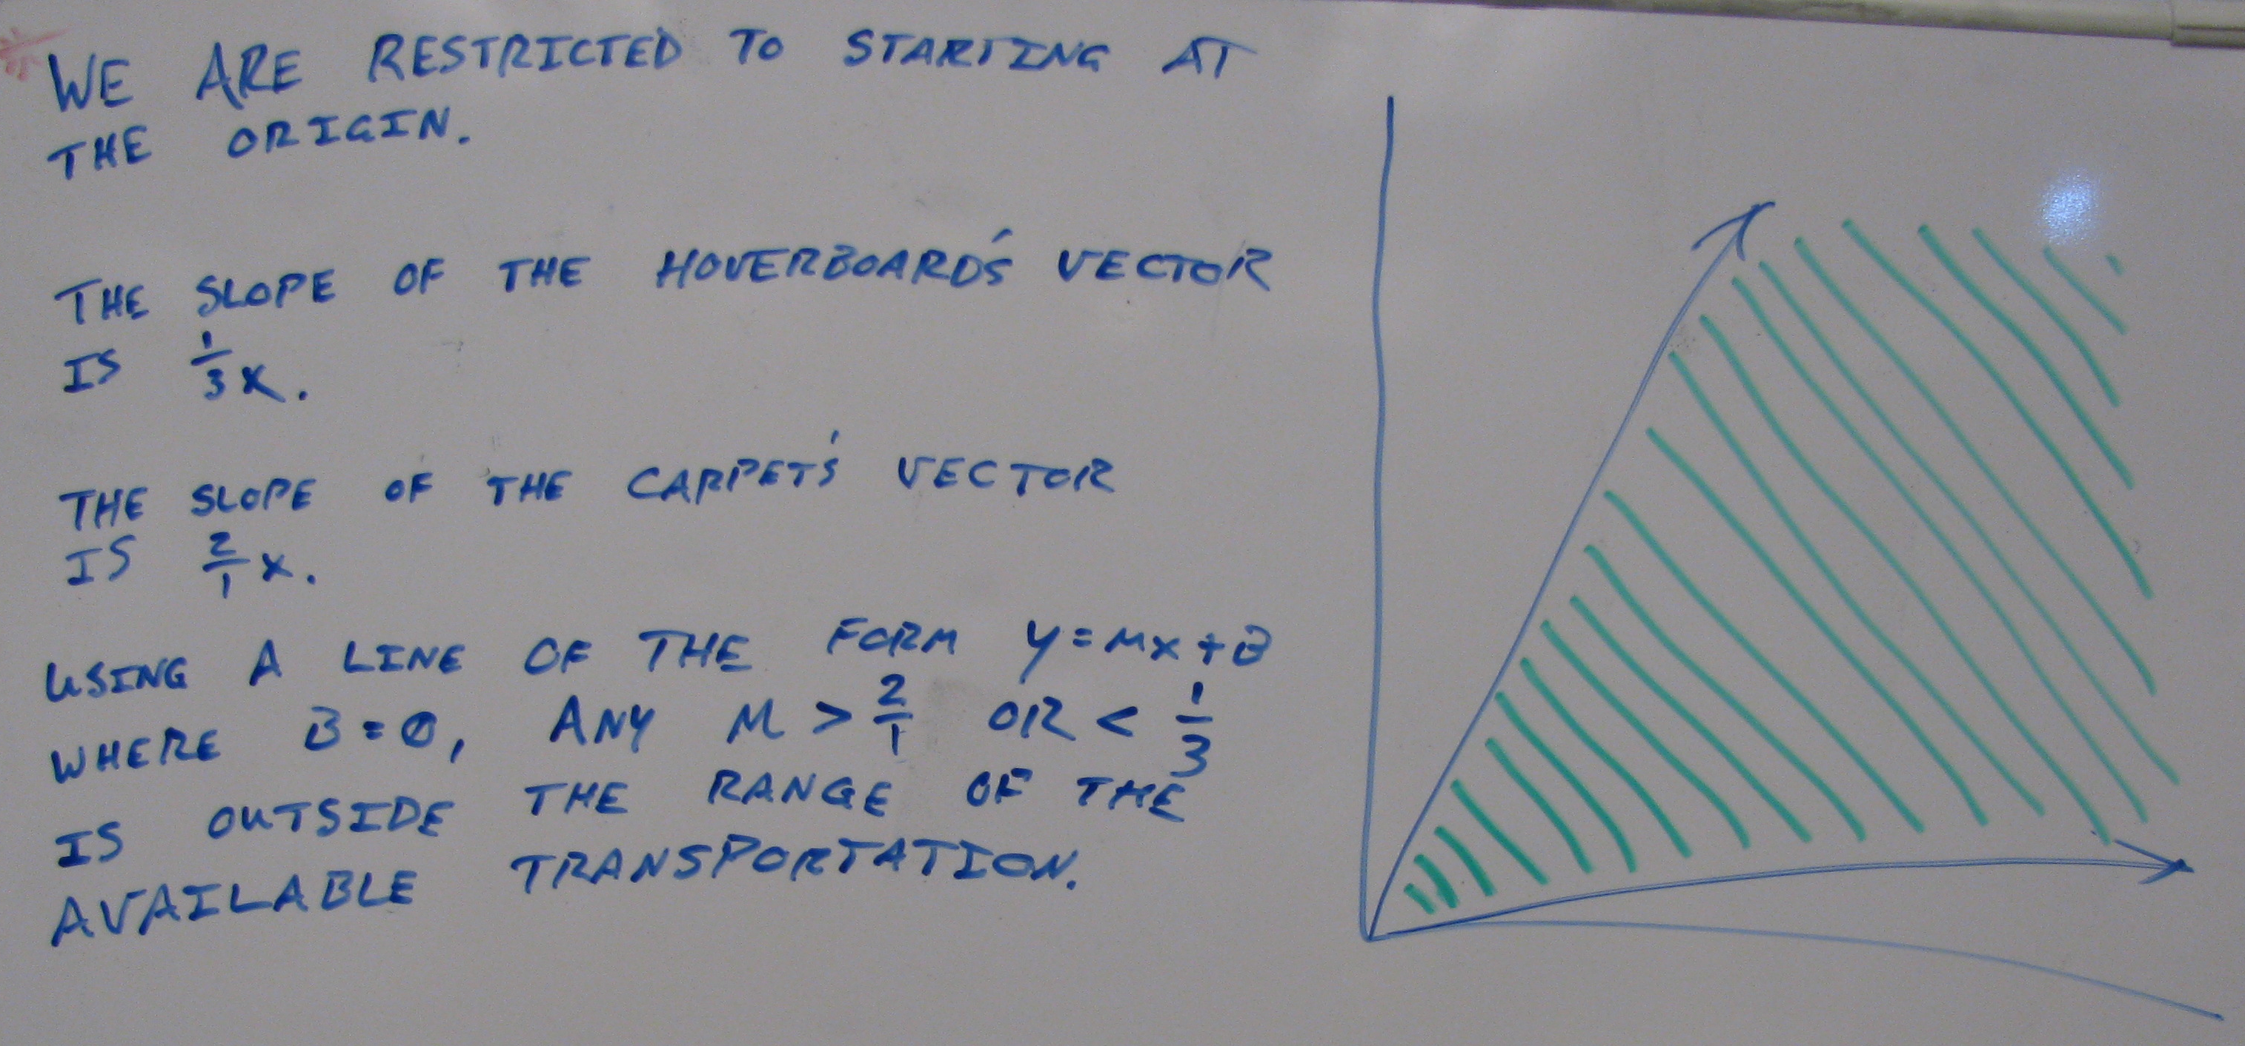

*“Cone” method*: This group argued that the only points that could be reached were the ones that lie “between” the cone traced out by the extensions of the two transportation vectors. Their argument was framed in terms of the slopes of the lines corresponding to the vectors when drawn from the origin. Notice this response is incorrect, most likely because students neglected to use negative scalars with the modes of transportation.

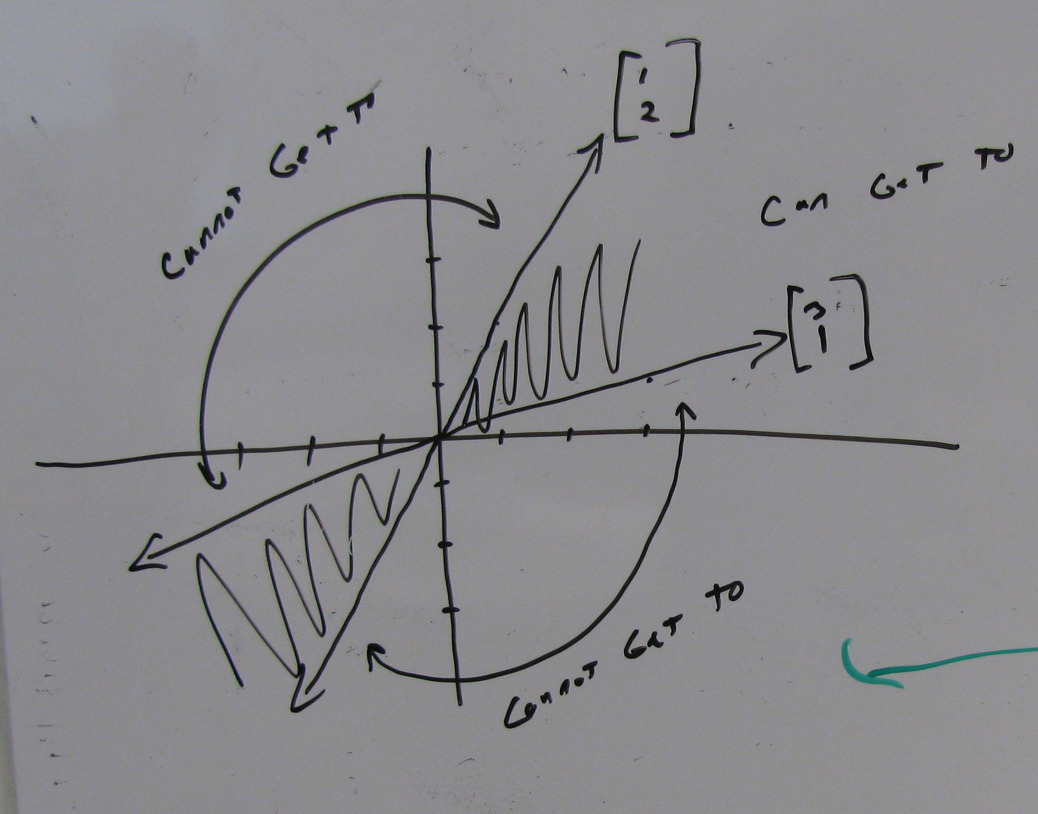

*“Double cone” method*: This group interpreted the sign of the scalar as an indication of whether they were moving forward or backward in time. So, in their interpretation, either both modes of transportation had to move forward (cone in first quadrant) or both had to move backward (cone in third quadrant).

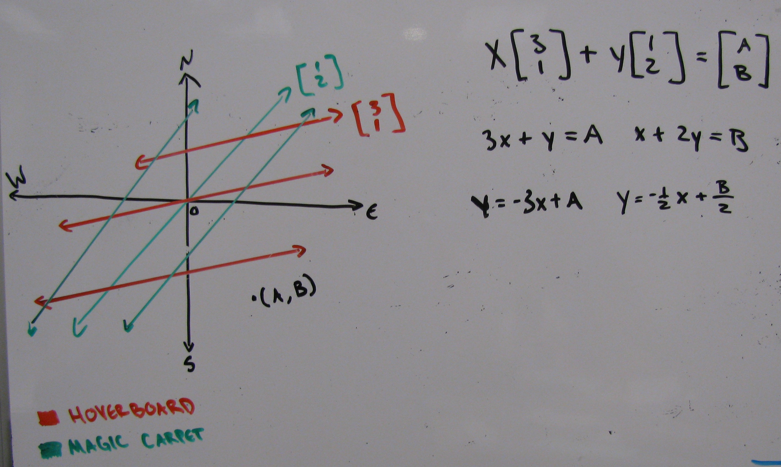

*“Grid” method*: This board and the one below illustrate the idea of "gridding" the plane with lines parallel to the two initial vectors. As part of the discussion a student asked, "Can we use any scalar to slide to any point on the graph?" This question was resolved by exploring when a vector equation equivalent to that shown at the top of this board had a solution.

*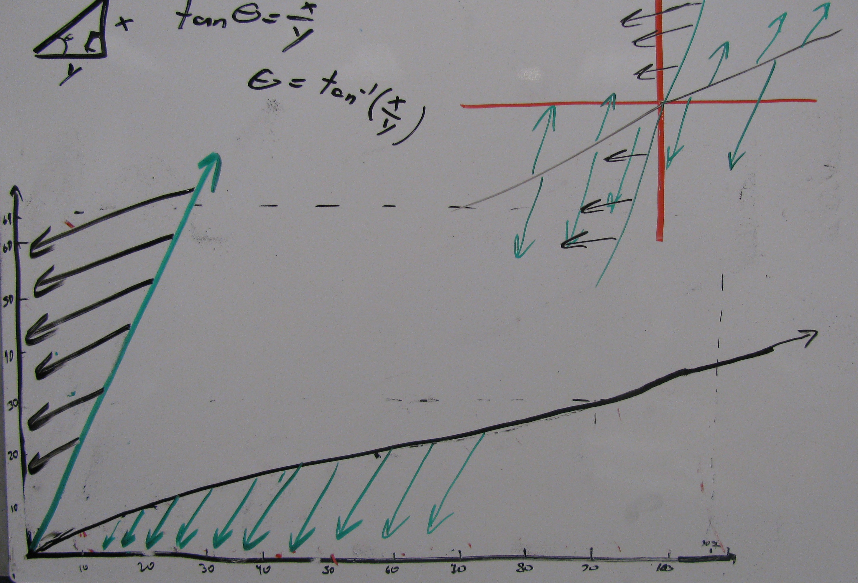“Sliding” method*: This group argued that you can reach any point on the plane by taking into consideration the ability to ride any given mode of transportation backwards. They explained that the portions of the graph that the Double Cone group deemed unreachable were accessible when considering that you can travel in the negative direction. For example, to travel to a point located in the 2nd quadrant, you travel in the positive direction a set distance with the magic carpet then travel in the negative direction with the hover board. Because each vector can be extended to any desired length through scalar multiplication, every point on the

graph is reachable. Their in-class description emphasized the metaphor of “sliding” the second vector along the first one to reach any point: “We can slide where we start riding our other mode of transportation, anywhere up and down. We can extend this [first] one to infinity each way, and then we just set the initial conditions of this [second] one anywhere we want on here.”

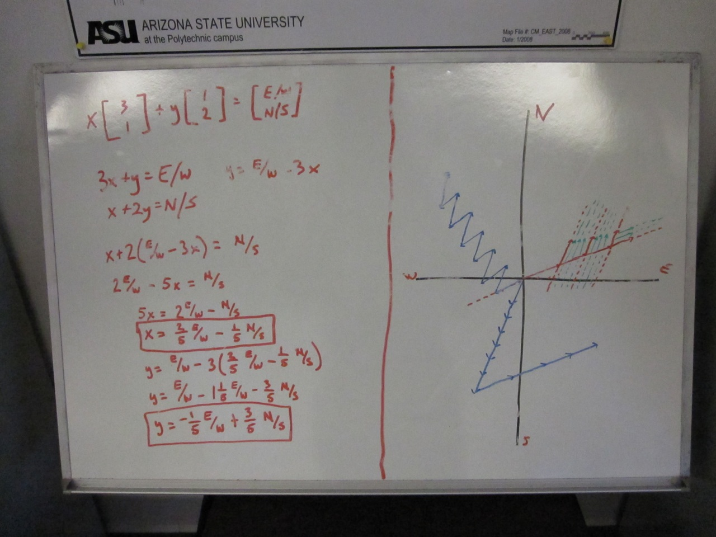*“Zig-Zag” method*: This group also used the “Grid” method. The green and red lines indicate a detailed gridding of that portion of the graph using vectors with the same direction as the original vectors. The blue vectors indicate what we call the “zig-zag” method. For this method, students imagined using each vector (mode of transportation) for a short time repeatedly. Alternating between the two modes creates a zig-zag appearance on the graph that helps convince some students that they can reach anywhere. In addition, this board illustrates a system of equations to help answer the question. The x-direction was set equal to an East/West (E/W) directionand the y-direction was

equated to a North/South (N/S) direction. Using substitution, the students solved for what x and y would have to be to reach any location with coordinates (E/W, N/S).

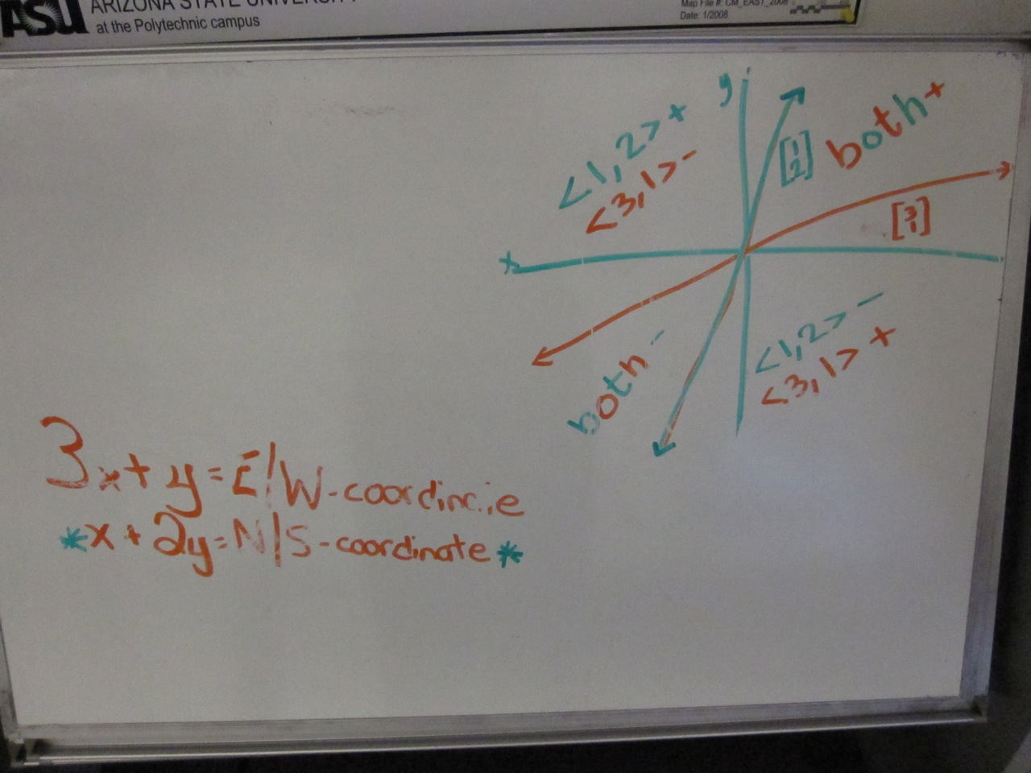“+,+;+,-“ *method*: For this white board the students extended the two vectors given for the modes of transportation to divide the plane into four spaces. They labeled each of the four spaces according to how one would travel to reach them. For example, if one travels forward on both modes of transportation (i.e., if both vectors are multiplied by a positive scalar), then the result is in the quadrant marked as “both +”. If one travels forward in the <1,2> direction and backwards in the <3,1> direction (i.e., the first vector is multiplied by a positive scalar and the second by a negative scalar), then the result is in the quadrant marked as “+, -.”

**Task 2 of the Magic Carpet Ride Task Sequence** **(Back to Top)**

**Handout 2: Hide-and-Seek**

**Implementation**

**Getting Started with the Task**

Depending on how long it has been since the students completed Task 1, you may want to review briefly some of the basic ideas and vocabulary from Task 1 such as vector, scalar, and vector equation. Remind students of the ability to multiply each vector by any real-valued scalar.

Point out to the students that in Task 1 they were trying to determine how to travel to **one** location, whereas Task 2 of this Magic Carpet Ride Sequence is to determine if one can get to **any** point on the plane using just these two modes of transportation.

**Working in small groups towards a solution**

While walking around to small groups, the instructor should note and encourage a wide variety of arguments, both geometric and symbolic. Students may not agree on whether there is a place where Gauss can hide and will hopefully display a wide variety of geometric arguments. Students should be encouraged to fully develop their arguments and/or complete a second argument if they have extra time during small group work. A wide range of solutions is most productive for whole class discussion.

**Discussing different solution strategies during whole class discussion**

Whole class discussion can be organized around various solution methods.

* **Numeric approaches (method of ‘guess-and-check’)**

Students may choose one or more specific locations and then determine the scalars that allow them to get there. They may generalize from this that because they can always find an answer, there is nowhere Gauss can hide.

* **Geometric approaches**

There are often a wide variety of geometric arguments presented by students, some correct and some incorrect. (White board illustrations of these can be found in Student Thinking on pp. 17-18.)

* + *“Zig-Zag” method*: In its simplest form, the zig-zag method is a geometric guess and check in that students are imagining travelling for various amounts of time on each mode, possibly in an alternating manner, and seeing which locations this leads them to. By trying a number of examples, it may convince students that by zigging and zagging enough, they can get to all locations.
  + *“Single cone and Double cone” methods*. Students argue that one can travel to any place in between the two vectors in the first quadrant (single cone) or in between the two vectors in both the first and third quadrant (double cone). These responses may come from the students implicitly or explicitly assuming that only positive scalars are allowed (single cone) or that the scalars on the two vectors must be both positive or both negative (double cone).
  + *“++;+-“ method*: These students realize that the scalars may be multiplied by four different sets of integers: both positive (++), both negative (--), or one of each (+-) and (-+). They may draw a graph with the two vectors extended to infinity in each direction and the four new quadrants that are created labeled with one of the four integer combinations. This method allows students to imagine reaching a point in any of their new quadrants, thus allowing them to reach any location on the plane.
  + “*Gridding” method*: The students create a gridding of the plane using the initial vectors extended and parallel versions of these vectors at regular intervals. This creates a coordinate system along which one can imagine travelling to reach all points on the plane.
  + *“Sliding” method*: The students argue that you can reach any point on the plane by imagining one vector extended infinitely in both directions from the origin and the second infinitely extended vector sliding along the first. As the second vector slides along the first it covers every point in the plane. To reach a point one slides along the first vector the correct amount and then moves along the second extended vector to reach the destination.

Points to bring out:

* + The Zig-zag method allows for whole class discussion regarding how adding multiple copies of the same two vectors in an alternating pattern can be rewritten as a linear combination of only two travel vectors used only once.
  + Discussing the single cone, double cone, and ++;+- methods allows for a review of what scalars are possible and how adding vectors with different signed scalars can be represented geometrically.
  + The ++;+- and gridding methods give a initial look at thinking of the plane in terms of a new basis, although this discussion is probably beyond the scope of the Task 2 discussion.
  + The sliding method is a type of covariational reasoning which may allow students an initial glimpse into the functional reasoning needed later when we think of varying inputs <x,y> to reach solutions <A,B> in the linear transformation T(<x,y>)=<A,B>, although discussion of this in detail is probably beyond the scope of the Task 2 discussion.
* **System of linear equations**

Students may set the vector equation equal to a variable location, e.g., $\left[\begin{matrix}A \\ B\end{matrix}\right]=c_{1}\left[\begin{matrix}3 \\ 1\end{matrix}\right]+c_{2}\left[\begin{matrix}1 \\ 2\end{matrix}\right]$ and then convert this into a system of equations.

* + Informally, students may argue that any system with two equations and two unknowns has a (unique) solution, so you can find a way to get to Gauss at any location. Students may not realize that although this system does have a unique solution, other systems will have no or infinitely many solutions.
  + To show that this system does indeed have a unique solution for any real numbers A and B, one can solve as follows:

$A=3c_{1}+c_{2}$

$B=c_{1}+{2c}_{2}$ and we get $c_{1}=\frac{2A-B}{5}$ and $c_{2}=\frac{3B-A}{5}$

So, for any location we want to reach <*A*, *B*>, there exists $c_{1}$ and $c_{2}$ as defined above, that will allow you to reach that location.

**Defining span**

At this point the students, although they don’t yet realize it, have a good intuitive sense of the span of two vectors in R2 that are not multiples of each other. The preceding solutions to the Hide-and-Seek problem give us that for any location we might want to reach $\left[\begin{matrix}A \\ B\end{matrix}\right]$ there exists $c_{1}$ and $c_{2}$ such that $\left[\begin{matrix}A \\ B\end{matrix}\right]=c_{1}\left[\begin{matrix}3 \\ 1\end{matrix}\right]+c_{2}\left[\begin{matrix}1 \\ 2\end{matrix}\right]$. In other words, any $\left[\begin{matrix}A \\ B\end{matrix}\right]$ in the plane can be written as a linear combination of $\left[\begin{matrix}3 \\ 1\end{matrix}\right]$ and $\left[\begin{matrix}1 \\ 2\end{matrix}\right]$. There is a technical word for the collection of all such vectors $\left[\begin{matrix}A \\ B\end{matrix}\right]$.The term is **span.** In determining that there is nowhere Gauss can hide, the students have discovered that the **span** of $\left[\begin{matrix}3 \\ 1\end{matrix}\right]$ and $\left[\begin{matrix}1 \\ 2\end{matrix}\right]$ is all of R2. In other words, Span $\left\{\left[{3 \atop 1}\right],\left[{1 \atop 2}\right]\right\}=R^{2}$.

We can also relate this back to the calculations in Task 1. We can see that $\left[{107 \atop 64}\right]∈Span\left\{\left[{3 \atop 1}\right],\left[{1 \atop 2}\right]\right\}$ because it can be written as a linear combination of those two vectors, i.e., $\left[\begin{matrix}107 \\ 64\end{matrix}\right]=30\left[\begin{matrix}3 \\ 1\end{matrix}\right]+17\left[\begin{matrix}1 \\ 2\end{matrix}\right]$.

We can now **define span** more generally:

* The **span** of a set of vectors is all possible linear combinations of those vectors, or in other words, all places you could reach with those two vectors.

* Span $\left\{v_{1},v_{2},…v_{p}\right\}$ is the collection of all vectors that can be written in the form $c_{1}v_{1}+c_{2}v_{2}+…+c_{P}v_{P}$ with $c_{1},c_{2,.}…,c_{p}$ with scalars.

**Example Practice Problems:**

Determine the following:

(a) Span $\left\{\left[{3 \atop 1}\right]\right\}$ (b) Span $\left\{\left[{2 \atop 3}\right],\left[{4 \atop 6}\right]\right\}$ (c) Span $\left\{\left[{1 \atop 3}\right],\left[{4 \atop 5}\right]\right\}$ (d) Span $\left\{\left[{1 \atop 3}\right],\left[{2 \atop -6}\right],\left[{4 \atop 5}\right]\right\}$

(e) Span $\left\{\left[\begin{matrix}1 \\ 3 \\ 2\end{matrix}\right],\left[\begin{matrix}1 \\ 4 \\ 5\end{matrix}\right]\right\}$ (f) Span $\left\{\left[\begin{matrix}0 \\ 0\end{matrix}\right],\left[\begin{matrix}2 \\ 3\end{matrix}\right]\right\}$ (g) Span $\left\{\left[\begin{matrix}-3 \\ 0 \\ -2\end{matrix}\right]\right\}$

These sets of vectors are specifically chosen to help students apply the definition of span and gain the understanding of the definition of span.

If time permits, you may want to ask questions of the format, “Is ___ in span{,}?” This is the format of a number of typical homework problems.

Broader discussion questions might be as follows:

**Example Discussion Question:**

Would any two vectors allow us to reach all points in the plane? If not, for what sets of vectors will

this not work? Why will a set of vectors of the type described [e.g., two vectors that are multiples]

not span the plane? What fails in the reasoning above that we had for $\left[\begin{matrix}3 \\ 1\end{matrix}\right]$ and $\left[\begin{matrix}1 \\ 2\end{matrix}\right]$?